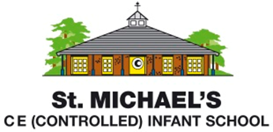
Statement of Intent for Religious Education
Through our Religious Education (R.E.) lessons at St Michael’s, we intend to:
- contribute to children’s personal development and our cohesive school community by promoting tolerance and reflecting the plurality of religious and non-religious traditions, experiences and ideas
- foster children’s spiritual development by giving them opportunities to pause, reflect and consider big questions
- provide a unique space within the curriculum where children can communicate their personal experiences, ideas and thoughts safely and in depth

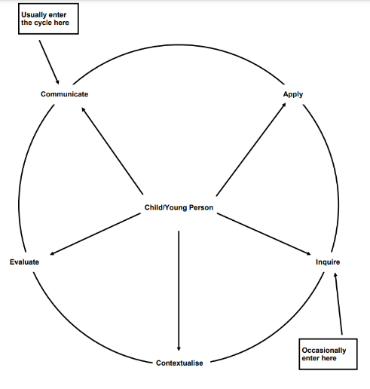
We follow the agreed syllabus for Hampshire, ‘Living Difference IV’, which states the purpose of R.E. as playing ‘an educational part in the lives of children and young people as they come to speak, think and act in the world. This entails teachers bringing children and young people first to attend to their own experience and that of others, to engage intellectually with material that is new and to discern with others what is valuable with regard to living a religious life or one informed by a non-religious or other perspective.’

Our high-quality R.E. teaching follows the interactive cycle of enquiry as set out in the Hampshire syllabus:
Teachers will:
- Begin the learning journey with an experiential moment so that the learning is meaningful and is
explicitly connected to each child’s own experiences
- Acknowledge the diversity of experiences children will bring to the concept studied and draw children’s
attention to similarities and differences between responses
- Guide children through the cycle of enquiry in creative ways, employing art, music, drama and
collaborative learning approaches
- Use case studies so that children can understand how the material studied relates to real-life contexts
- Provide time for children to reflect and question

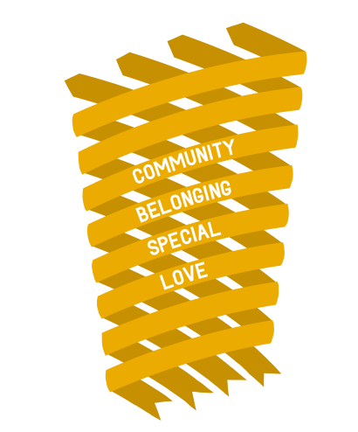
.Each year group will study one concept each half-term. In line with all schools in Hampshire, children will study the ‘golden thread’ concepts of love, belonging, community and special over their time with us.

We have selected additional concepts which are relevant and meaningful to the children, but also challenging, allowing children the opportunity to discuss ‘big questions’ and to gain insight into how they might grow and develop as a person. For example, as part of the Year R unit on ‘Friendship’, children reflect upon what makes a good friend and display ideas to help them form positive relationships in the future. During the Year 2 unit on ‘Peace’, children have the chance to learn about what helps others to feel peaceful and consider which of these strategies might enhance their own lives.
In Year R and Year 1, the concepts studied are those which are common to all people, such as friendship. By the end of Year 2, children also learn about some concepts which are shared by many religions, such as creation. Each cycle begins with the children sharing their own experiences and understanding of the concept, before finding out more about it in the context of either the Christian or Hindu traditions and then having time to reflect upon its value to themselves and others.

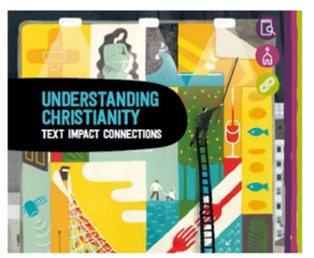

We have chosen to use the ‘Understanding Christianity’ resource to support the Christian units that we teach. It is a great tool for helping children to understand the ‘big story’ Christians read about in the Bible and ensures that the children’s learning about key Christian concepts progresses securely over the three years they are with us.

