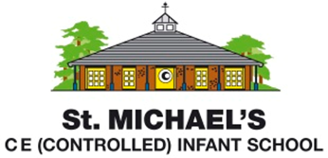
Statement of Intent for Geography
Through our Geography teaching at St. Michael’s Infant School, we aim to:
- Inspire curiosity and fascination about the world and its people
- Give children opportunities to investigate and enquire about places that are meaningful to them and our school community
- Support children to develop an understanding of their local area as part of their sense of identify and place within the world
- Help children to develop an increasingly complex understanding of place over time
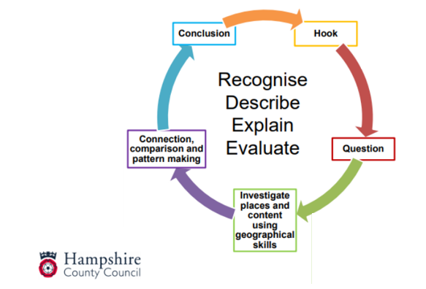
- Guide children to develop an appreciation of the diversity of the places studied

Through each unit in KS1, we follow the Hampshire cycle of enquiry for Geography:

We recognise that enquiry-based learning in Geography supports the development of children’s disciplinary knowledge and gives purpose and meaning to children’s learning. Within each year group, one unit also has a local study focus, which provides children with the opportunity to carry out fieldwork and create maps based on first-hand experiences. Geographical vocabulary is explicitly planned for and taught so that children are able to express observations, comparisons and evaluations of places with increasing accuracy and precision.

