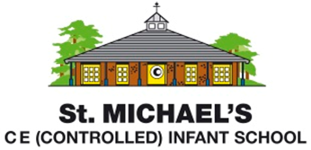
Statement of Intent for Art
Through our art teaching at St. Michael’s Infant School, we intend to:
- Encourage every child to see themselves as an artist
- Provide a well-balanced and enjoyable curriculum for every child which engages, inspires and challenges them to express their feelings about the world around them
- Promote the development of individual creativity, by giving children opportunities to research, experiment and develop their own ideas within a safe and encouraging environment
- Give children the opportunity to reflect on the work of a diverse range of great artists, craft makers and designers, and use this as a stimulus for their own creations
- Support children to develop their skills progressively over time in the areas of drawing, painting, textiles, collage and sculpture

Our teaching of art skills and techniques is structured using the following cycle:
- Immersion in the artist or stimulus
- Identify and exemplify the skills and techniques
- Teach the skills, giving children opportunities to practise and refine these
- Model how to apply and combine these skills to create a final art product
- Evaluate the project, making links to the original stimulus

The emphasis is always on the process and not just the end product. Children are taught to think critically about the work of others and their own work, through group conversations, peer, and self-assessment. Children will research and deepen their knowledge of great artists, craft makers and designers, whilst developing their own opinions on a variety of art works.

